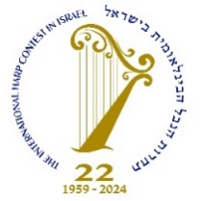

The 22nd International Harp Contest in Israel
13 August – 26 September 2024

Official Application Form

First Part:

(Please Print)
Last Name: |  | First Name:
Date of Birth: | Place of Birth: |  | Nationality:
Permanent Address:

Tel. | Fax. |  | Cell:
Email:

Present Address:

Address between 01 May 2024 – 01 July 2024:

Second Part:

- I will bring my own harp: Yes/No

- I will be accompanied by persons and request accommodation:

In the same hotel with me: Yes/No
In an extra room: Yes/No

(Please note - payment for accompanied persons to be paid by contestant)

- I have read and hereby accept the Rules and Regulations of the Contest. I agree to adhere to its Rules and Regulations and will accept, without appeal, any and all decisions of the Jury.

- I agree to perform, without remuneration, for Radio, TV, Video, CD, DVD, social media and public concerts, during the Contest.

- If I will become a Prize Winner, any of the prizes, I agree to perform either in a concert after the competition and/or I will perform a short piece after the Prizes Distribution, on request.

- All performer's rights of my performance shall belong to the contest which will have sole rights of distribution in any and all media. I undertake not to show a copy of my recorded performance to any person or body corporate prior to the official broadcasting of my performance.

Please note:

All documents (apart from copies of programs, diplomas, and awards) must have an English translation attached if original is not English.

Applicant's Name ……………………………….

Date…………………….…………………………

………………………..………………….
Applicant's signature

